EVALUATION AGAINST DESIGN SPECIFICATION
FUNCTION
SPECIFICATION |  | EVALUATION
1 | To construct a bird table that portable and easy to set up | Achieved. No component weights more than 8kg and the table can be broken down into multiple components to help with lift and carry
2 | To construct a bird table that is stable and rigid | Achieved. The base has 4 legs and spans over a metre (More than 50% of the table height of ~180cms). The centre post, which supports table, roof and bath, is of sufficient cross sectional area to prevent flexing. The bath can be located on the opposite side of the post to the feeding table to help balance.
3 | To construct a bird table that has a customisable configuration with separate/optional components | Partially Achieved. The bird table includes 3 components (table, roof and bath) which can be arranged at different heights and orientations. The centre post has holes every 15cms which hold pegs on which components can sit and height can vary. Components slide up and down the centre post and can therefore face backwards or forwards. Other components can be added (e.g. commercial hanging feeders). In practice the roof can only be located at the top of the post
4 | To construct a bird table that repels unwanted visitors (e.g. pigeons and squirrels) | Partially Achieved. The feeding table contains a force sensitive resistor which measures the weight of visitors. If the weight is above that of a small garden bird the visitor is scared away by a flashing owl face and “screech”. One issue is the calibrating the resistor to trigger at the correct weight. It is important not to repel small birds as they may be scared away for good.
5 | To construct a bird table that records information about visitors (e.g. photos, time, temperature) | Achieved The table unit includes a compartment containing a wildlife camera which takes photos and videos of visitors which can be reviewed later. A wrist watch unit logs time and temperature on the images.
6 | To construct a bird table that provides safe feeding for small garden birds | Achieved The feeding table can be located at a safe height and provides an all-round view of potential predators. The table is rigid and stable.
7 | To construct a bird table that provides a bath/water for small garden birds | Achieved. The bird table includes a water bath that allows birds to bath and drink. The bath can be located on the opposite side of the post to the feeding table to avoid food falling into it
AESTHETICS
SPECIFICATION |  | EVALUATION
1 | To construct an exciting and interesting looking bird table | Achieved. User feedback has been very positive. A “tiled” roof and choice of colours added to the overall appeal. The solar powered water fountain produces a calming sound.
2 | To construct a bird table that attracts small garden birds | Achieved. A variety of species of birds were soon feeding at the table
3 | To achieve an attractive, natural painted finish | Achieved Except for the roof, which is painted in a sky coloured blue, the table is painted in a natural matt green colour that blends in with the grass and plants found in gardens
COST
SPECIFICATION |  | EVALUATION
1 | To construct a bird table at a cost of less than £50 (excluding labour, circuit and camera) | Achieved. Estimated cost £50 (including £15 for birdbath)
2 | To construct an system that repels unwanted visitors at a cost of less than £50 | Achieved. Estimated cost £40 (including £20 for Arduino Uno board)
JUSTIFYING THE PROJECT
SPECIFICATION |  | EVALUATION
1 | To safely feed and water small garden birds and aid their survival | Achieved. The tables attracts small garden birds
2 | To avoid feeding and encouraging vermin | Partially Achieved. Pigeons, Magpies, Jays and Squirrels are repelled when the detection process functions correctly
3 | To automatically gather garden bird information to support research (e.g. RSPB Big Garden Birdwatch) | Partially Achieved. The camera will take pictures of birds using the table which can be reviewed later. Some species might not use tables and would not be counted
TARGET MARKET
SPECIFICATION |  | EVALUATION
1 | This product is aimed customers who to feed small garden birds but not large birds and squirrels | User feedback has been very positive
2 | This product is aimed customers who want to record information about small garden birds | User feedback has been very positive
SIZE
SPECIFICATION |  | EVALUATION
1 | The bird table components must be light enough to be carried by an adult | Achieved. The heaviest component is the feeding table which weights 8kg . The largest component is post which is 180cm in length
2 | The bird table must be able to fit into a car | Partially Achieved. Because the post is ~180cm long a large or estate car with back seats down is needed
DURABILITY
SPECIFICATION |  | EVALUATION
1 | The bird table must be weather proof (e.g. rain and wind) | Partially Achieved. Wide base. Sloping roof. Roof covers table. Under some conditions rain could enter the circuit and camera boxes through the holes at the front.
2 | The bird table must be protected against rot to maximise life | Achieved. All wood surfaces have been treated with a modern wood preservative
SAFETY
SPECIFICATION |  | EVALUATION
1 | All sharp edges must be removed to prevent cuts | Achieved. Plywood is easily sanded and there are no sharp edges
2 | The bird table must be able to be moved and setup without risk of injury | Achieved. No component weights more than 8kg and the table can be broken down into multiple components to help with lift and carry
3 | The bird table must be able to be used without risk of injury | Achieved. The bird table is stable.
TESTING
SPECIFICATION |  | EVALUATION
1 | Prove unwanted visitor detect and repel capability | Achieved.
2 | Prove small garden bird feeding capability | Achieved.
3 | Prove small garden bird information gathering capability | Achieved.
4 | Prove solar powered fountain functions | Achieved.

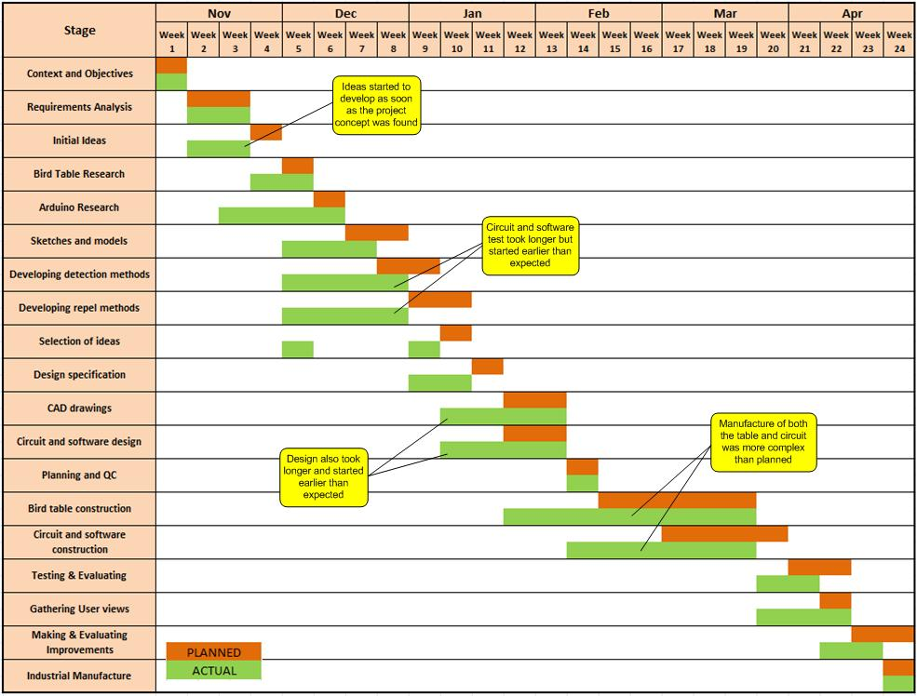
EVALUATION OF ACTION PLAN

